EVENT DESCRIPTION SHEET
(To be filled in and uploaded as deliverable in the Portal Grant Management System, at the due date foreseen in the system.
Please provide one sheet per event (one event = one workpackage = one lump sum).)
PROJECT
Participant: | 1 – Municipality of Janíky, Janíky
PIC number: | 904993608
Project name and acronym: | Beats of Solidarity Festival: Stretnutie partnerských obcí v Janíkoch pri príležitosti Hornožitnoostrovského kultúrneho festivalu 2026 — BOSF 2026

EVENT DESCRIPTION
Event number: | 101292308
Event name: | Beats of Solidarity Festival: Stretnutie partnerských obcí v Janíkoch pri príležitosti Hornožitnoostrovského kultúrneho festivalu 2026
Type: | Opening ceremony, Q&A session, Workshop, Presentation, Civic dialogue, Panel discussion, World Café, Social and cultural activities, Signing Ceremony
In situ/online: | in-situ
Location: | Slovakia, Municipality of Janíky
Date(s): | 14/08/2026 – 16/08/2026
Website(s) (if any): | www.janiky.sk
Participants
Female: | 191
Male: | 182
Non-binary: | 2
From country 1 [Slovakia]: | 200
From country 2 [The Czech Republic]: | 42
From country 3 [Hungary]: | 85
From country 3 [Slovenia]: | 24
From country 3 [Serbia]: | 24
Total number of participants: | 5 | From total number of countries: | 375
Description
Provide a short description of the event and its activities.
The BOSF 2026 event took place over three days in Janíky, Slovakia, gathering citizens, civil society representatives, youth, seniors and partner municipalities from Slovakia, the Czech Republic, Hungary, Slovenia, and Serbia. The event focused on solidarity, inclusion, democratic participation, and the application of New European Bauhaus principles in local community life. The programme combined cultural activities, civic dialogue, workshops and participatory decision-making, resulting in the co-creation of the Declaration of Open Municipalities 2026.
Day 1 – Friday, 14 August 2026
Theme: Our Europe, Our Municipalities – Culture for All
The first day began with the arrival and registration of participants, followed by informal networking and a guided tour of Janíky for early arrivals. The official opening ceremony included a welcome speech by the Mayor of Janíky and presentations from partner municipalities showcasing local achievements, EU-funded projects, and initiatives promoting solidarity and cooperation.
A key activity of the day was the panel and workshop on “Inclusive Public Spaces for Women, Children and Vulnerable Groups”, inspired by the New European Bauhaus. Best practices were presented from Slovakia, the Czech Republic, and Serbia, followed by interactive group discussions on accessibility, inclusion, and community needs. Participants jointly developed concrete proposals, which were collected as input for the final Declaration.
In the evening, a welcome dinner and cultural programme took place, featuring regional cuisine, folklore performances, and informal networking. Inclusive measures ensured participation of all target groups, including children’s activities, sign language interpretation, barrier-free access, and engagement tools for youth and persons with disabilities.
Day 2 – Saturday, 15 August 2026
Theme: Inclusive Municipalities – Local Government Open to All
The second day focused on civic participation, inclusion and local governance. The morning workshop addressed prevention of domestic violence and cyberbullying, led by an expert from an NGO supporting victims of violence. Participants worked in groups to develop recommendations for municipalities, with a strong focus on protection of women and children.
This was followed by a civil dialogue with mayoral candidates of Janíky, allowing citizens to directly engage in discussions on representation, accessibility, youth involvement and inclusion of minorities, supported by interactive voting tools.
A youth session enabled young participants to present their ideas for improving municipalities and Europe, with peer voting for the most inspiring proposal.
In the afternoon, a panel discussion and World Café titled “Municipalities for All” brought together representatives of women’s organisations, persons with disabilities, minorities and youth. Participants co-created practical proposals for inclusive local governance.
The day concluded with the “Beats of Unity” cultural festival, offering concerts, exhibitions, family activities, sports and community celebrations.
Day 3 – Sunday, 16 August 2026
Theme: Finalising the Declaration of Open Municipalities
The final day combined informal networking with structured decision-making. Participants took part in rafting on the Little Danube, highlighting natural heritage as a space for cross-border cooperation and solidarity, followed by a picnic breakfast fostering informal dialogue.
A World Café session focused on finalising proposals for the Declaration of Open Municipalities 2026, addressing issues such as violence prevention, democratic trust, accessibility, youth engagement and inclusion of minorities and seniors.
After a farewell lunch and feedback collection, the official Signing Ceremony of the Declaration of Open Municipalities 2026 took place. The document was signed by mayors and civil society representatives and symbolically handed over by citizens representing diverse groups, including women, youth, seniors, persons with disabilities and minorities.
The event successfully combined cultural exchange with participatory democracy, resulting in strengthened cooperation between municipalities, increased civic engagement and the adoption of a jointly developed Declaration promoting solidarity, inclusion, and democratic resilience at the local level.

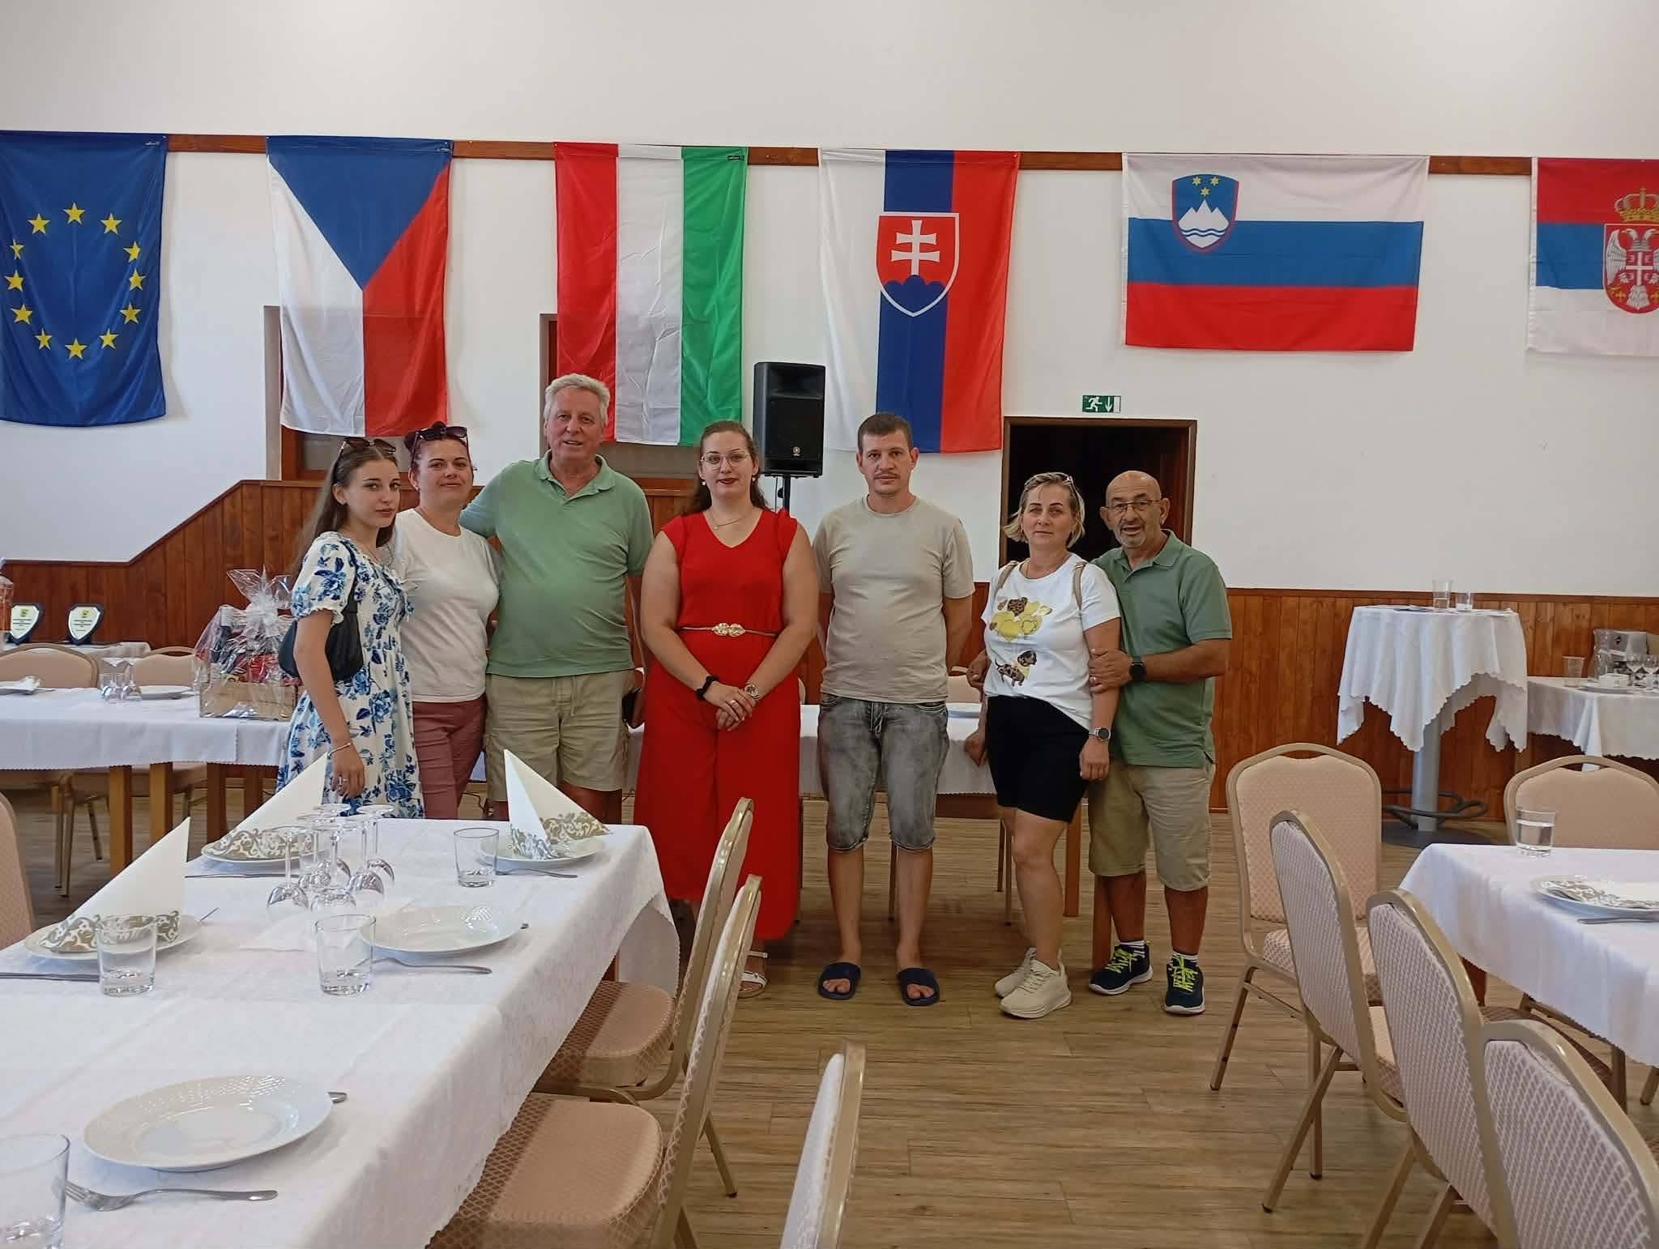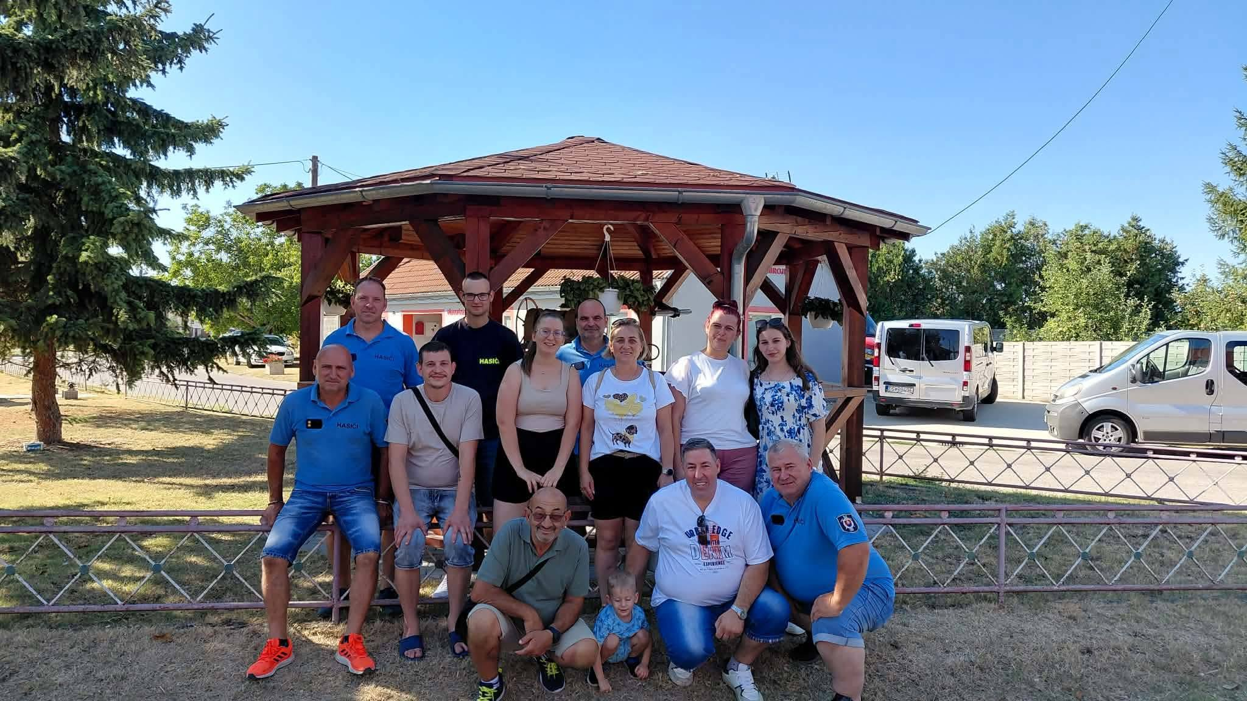
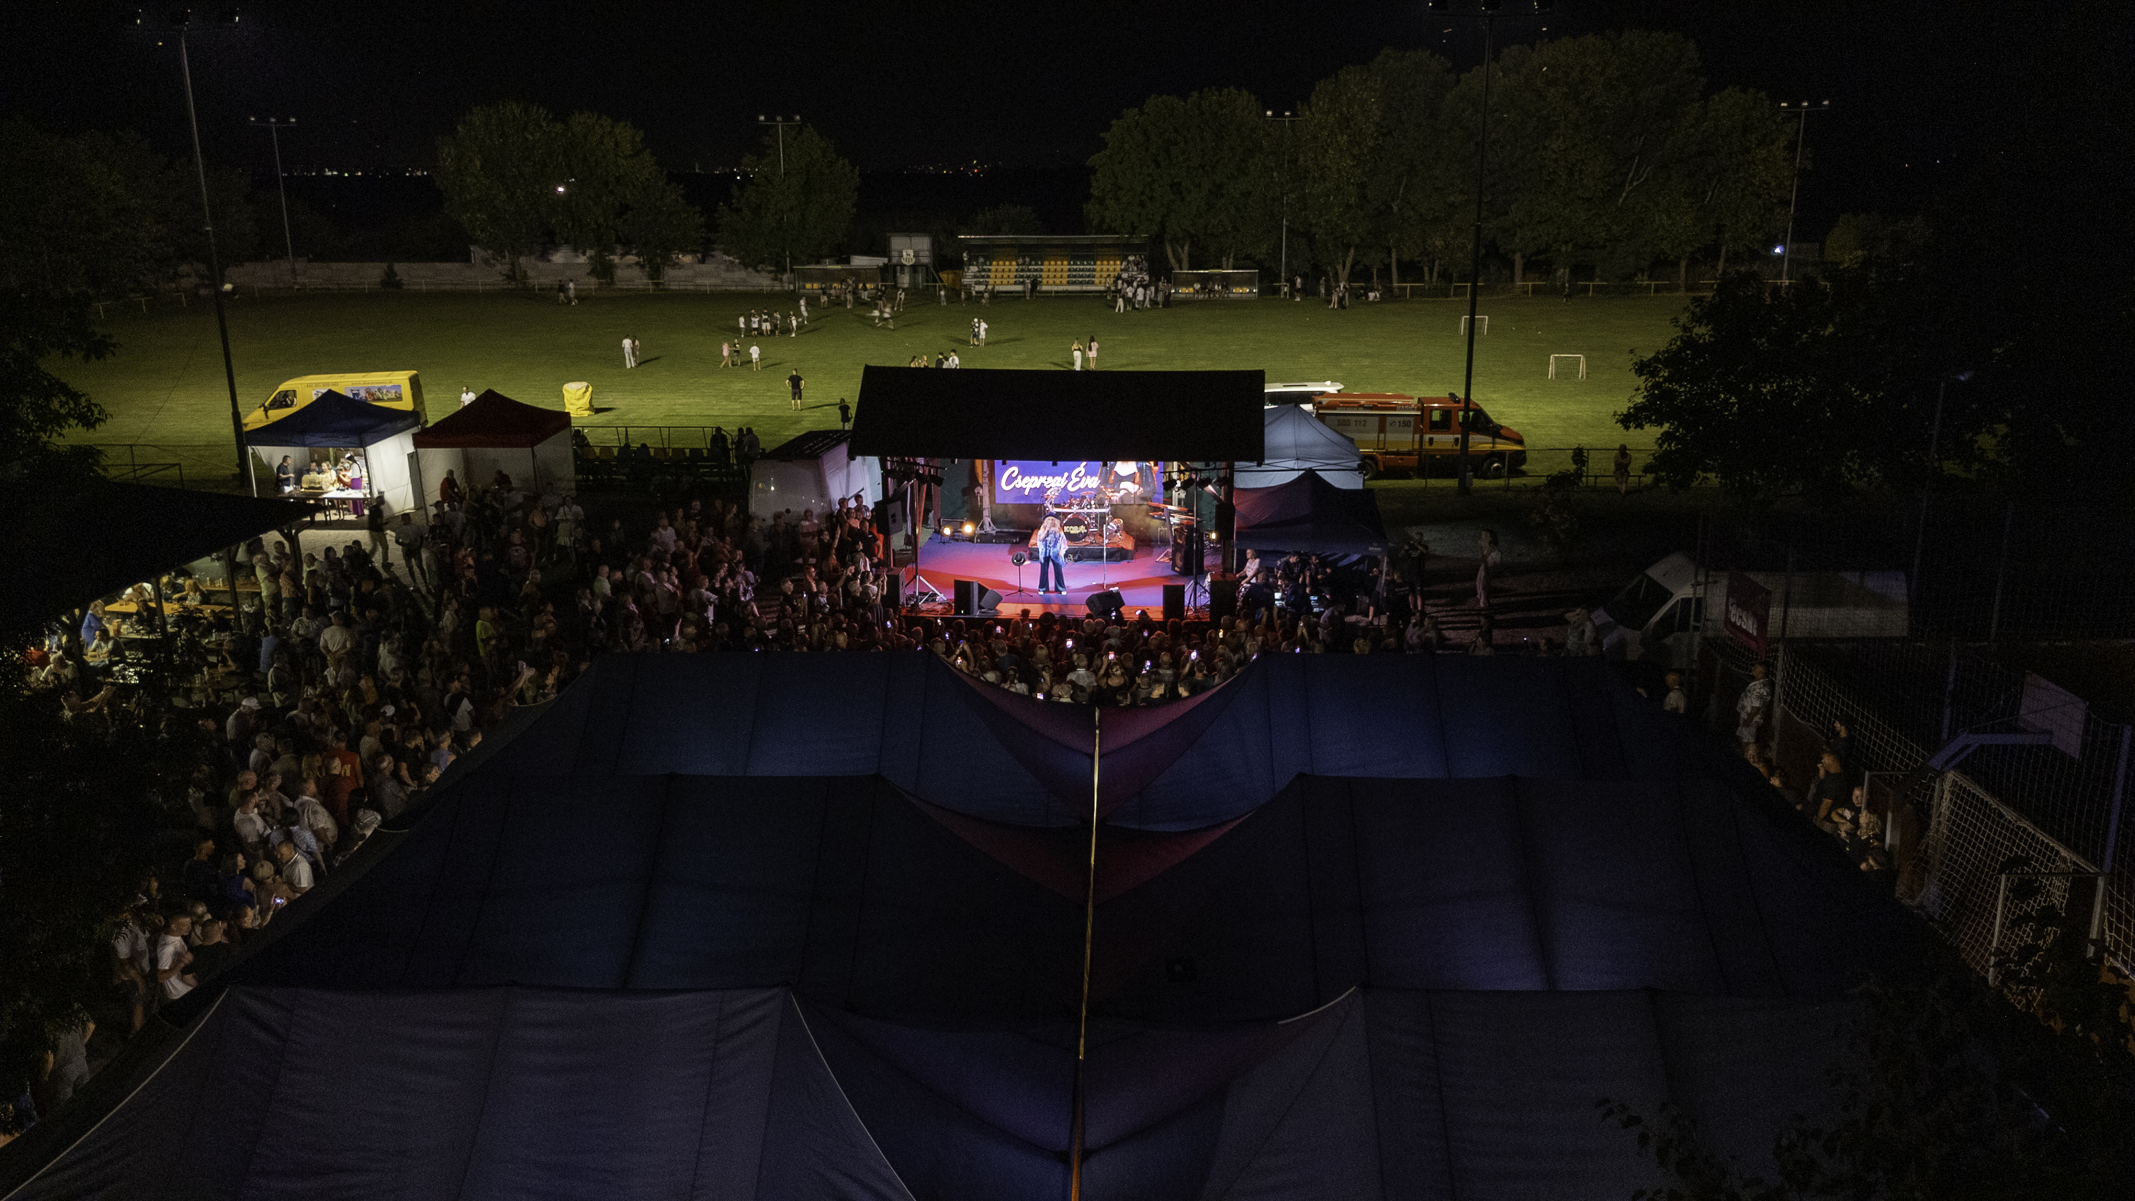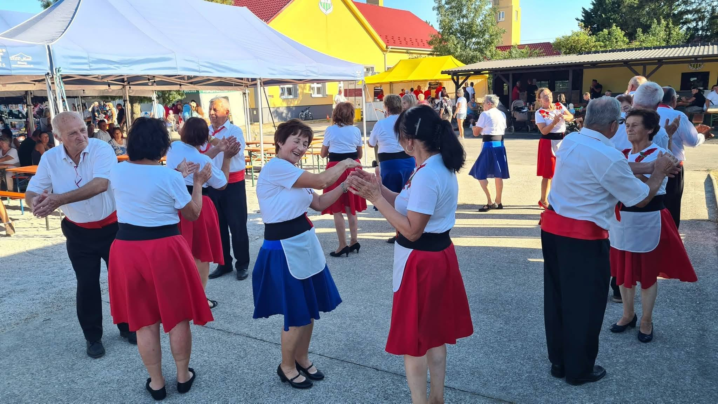

HISTORY OF CHANGES
VERSION | PUBLICATION DATE | CHANGE
1.0 | 01.04.2022 | Initial version (new MFF).

